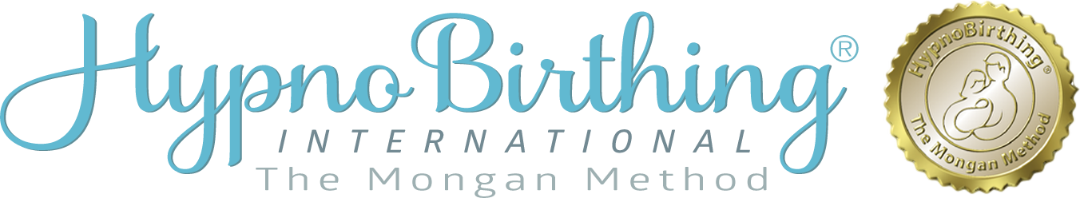
Course Enrollment Form

_____________________________________________________________________________________
Pregnant Person’s Name Please circle your pronoun: She / He / They

_____________________________________________________________________________________
Please circle or fill in your identifying term for use in the birth journey:
Mom, dad, birthing person, parent, other______________________________.

_____________________________________________________________________________________ Mailing Address

_________________________________________ Preferred contact phone | _______________________________________ Alternate phone
_________________________________________ Email Contact

_________________________________________ _______________________________________
Birthing Companion Name Relationship

_______________________________________________________________________________________
Please circle or fill in your Birthing Companion’s identifying term for use in the birth journey: mom, dad, birthing companion, parent, or other________________.

__________________________________________ Birthing Assistant Name | _______________________________________ Relationship (doula, friend, etc.)
__________________________________________ Care Provider Name & Title | _______________________________________ City
__________________________________________ Birthing Facility | _______________________________________ City
__________________________________________  Have you given birth before? | _______________________________________  How did you hear about us?
__________________________________________  When is baby expected? | _______________________________________  How many weeks pregnant will you be when you begin classes?
Do you have any health or obstetric concerns?

I wish to enroll for the five Week HypnoBirthing® Course beginning:

Date: Location :

Tuition fee: $450.00 (fee includes textbook, workbook, digital downloads, and supplemental material).

To secure your place in the course, a $100.00 non-refundable tuition deposit is required.
Payment can be made via Zelle to (954) 993-5156 or via Venmo to @Helen-Citrin

Please return your form to: helen@sacredbirths.com

Enrollment Agreement

I hereby state that I am enrolling in the HypnoBirthing® class of my own free will and with the understanding that this is a program designed to teach me to use my own natural abilities to bring my mind and my body into a state of relaxation. I further understand that the content of these classes is in no way intended to be represented as medical advice nor as a prescription for medical procedure. I am aware that I should seek the advice of a health-care provider to answer any health-related or pregnancy-related issues surrounding my pregnancy, my labor, or my birth.

I therefore agree that I will in no way hold the instructor of the HypnoBirthing® classes, or the HypnoBirthing Institute®, its owner, or its representatives responsible for any special circumstances that could arise as a result of my pregnancy, my labor, or the birth of my child; and I agree that neither I nor any member of my family will make any claim or initiate any suit against any of the above-named parties now or at any time in the future.

Pregnant Person’s Signature Date

